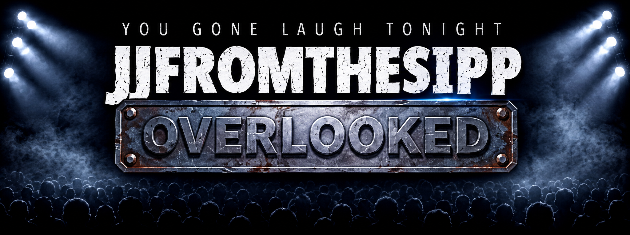
JJFROMTHESIPP
2026 OFFICIAL BIO PACKAGE
“RESPECK MY COUNTRYNESS.”
OVERLOOKED — His Moment. His Time.

JJFROMTHESIPP
OFFICIAL INDUSTRY BIO
RESPECK MY COUNTRYNESS

Jeremiah “JJ” Williamson, professionally known as JJFROMTHESIPP, is a comedian, actor, and nationally syndicated radio personality from Jackson, Mississippi. An OG of stand-up comedy with more than three decades in entertainment, JJ has built a career distinguished by his unmistakable country flava, Southern storytelling, charismatic wit, and uncanny ability to connect with audiences across generations. His signature declaration, “Respeck My Countryness,” embodies the Mississippi roots and unapologetically Southern perspective at the heart of his comedy.
For more than 30 years, JJFROMTHESIPP has performed across the United States and internationally, working alongside and sharing stages with some of comedy’s most recognizable names, including Cedric “The Entertainer,” Chris Tucker, D.L. Hughley, Rickey Smiley, Earthquake, Sommore, Bruce Bruce, DeRay Davis, and Lavell Crawford. His longstanding relationship with Cedric the Entertainer has included years of touring as an opening act, bringing JJ’s signature Mississippi-bred comedy to audiences around the world.
His stand-up career has taken him to some of the country’s most recognized comedy clubs and entertainment venues, including The Comedy Store in Los Angeles, the Los Angeles and Miami Improvs, Chicago’s House of Blues, Caroline’s in New York, and Harlem’s legendary Apollo Theater. His international work has also included entertaining U.S. troops in Korea.
JJ’s versatility extends well beyond the stand-up stage. He made his feature-film debut as the unforgettable Cousin Bodie in Johnson Family Vacation alongside Cedric the Entertainer, Vanessa Williams, Bow Wow, and Steve Harvey. His television credits include appearances on HBO and BET, as well as Russell Simmons’ Def Comedy Jam, The Mo’Nique Show, BET’s ComicView, Laffapalooza and Cedric the Entertainer Presents.
His stand-up catalog also includes LOL! Stand Up Presents: JJ Williamson, released through Kevin Hart’s LOL! Network, adding another nationally distributed stand-up credit to a body of work spanning comedy clubs, theaters, television, film, radio, and digital entertainment.
Today, JJFROMTHESIPP reaches audiences every weekday as a co-host of the nationally syndicated DeDe in the Morning radio show, where his humor, perspective, quick wit, and unmistakable Southern personality have become part of his connection with listeners across the country.
OVERLOOKED — His Moment. His Time.
In August 2026, JJFROMTHESIPP entered a defining new chapter with the independent release of his first full-length stand-up comedy special, JJFROMTHESIPP: OVERLOOKED, on YouTube.
Within its first week, OVERLOOKED surpassed 200,000 views, generated more than 56,000 hours of watch time, and reached nearly 3 million YouTube impressions. More than 80% of its impressions came through YouTube recommending the content, while the special maintained a 99%+ positive audience rating as it reached viewers far beyond JJ’s established fan base.
The response represents more than a digital milestone. OVERLOOKED brings together more than three decades of experience built before algorithms, social media, and streaming transformed how audiences discover comedy. From intimate comedy clubs to major theaters, television sets, movie screens, radio studios, and international stages, JJFROMTHESIPP has spent his career developing a voice and point of view that are unmistakably his own.
Now, a new generation of viewers is discovering what audiences and fellow comedians have known for years. JJFROMTHESIPP continues to tour, create, act, entertain nationally syndicated radio audiences, and expand his presence across digital platforms while remaining rooted in the authenticity that has defined his career from the beginning.
Southern without limitation. Seasoned without losing spontaneity. Relatable across generations.

“RESPECK MY COUNTRYNESS.”
OVERLOOKED — His Moment. His Time.
“Preciate Dese Few Giggles.”

JJFROMTHESIPP
STANDARD PROFESSIONAL BIO
RESPECK MY COUNTRYNESS

Jeremiah “JJ” Williamson, professionally known as JJFROMTHESIPP, is a comedian, actor, and nationally syndicated radio personality from Jackson, Mississippi. An OG of stand-up comedy with more than three decades in entertainment, JJ is known for his country flava, Southern storytelling, charismatic wit, and unmistakable ability to connect with audiences across generations. His signature declaration, “Respeck My Countryness,” embodies the Mississippi roots and unapologetically Southern perspective at the heart of his comedy.
Throughout his career, JJFROMTHESIPP has worked alongside and shared stages with comedy standouts including Cedric “The Entertainer,” Chris Tucker, D.L. Hughley, Rickey Smiley, Earthquake, Sommore, Bruce Bruce, DeRay Davis, and Lavell Crawford. His longstanding relationship with Cedric the Entertainer includes years of touring as an opening act.
JJ portrayed the memorable Cousin Bodie in Johnson Family Vacation and has appeared on HBO, BET, Russell Simmons’ Def Comedy Jam, The Mo’Nique Show, ComicView, Laffapalooza and Cedric the Entertainer Presents. His stand-up catalog also includes LOL! Stand Up Presents: JJ Williamson, released through Kevin Hart’s LOL! Network.
Today, JJFROMTHESIPP is a co-host of the nationally syndicated DeDe in the Morning and continues performing for audiences nationwide.
In August 2026, he independently released his first full-length stand-up comedy special, JJFROMTHESIPP: OVERLOOKED, on YouTube. Within its first week, the special surpassed 200,000 views, generated more than 56,000 watch hours, and reached nearly 3 million YouTube impressions, marking a powerful new chapter in a career more than three decades in the making.

“RESPECK MY COUNTRYNESS.”
OVERLOOKED — His Moment. His Time.
“Preciate Dese Few Giggles.”

JJFROMTHESIPP
SHORT PROFESSIONAL BIO
RESPECK MY COUNTRYNESS

Jeremiah “JJ” Williamson, professionally known as JJFROMTHESIPP, is a comedian, actor, and nationally syndicated radio personality from Jackson, Mississippi. An OG of stand-up comedy with more than three decades in entertainment, JJ is known for his unmistakable country flava, Southern storytelling, and signature declaration, “Respeck My Countryness.”
His credits include Johnson Family Vacation, Def Comedy Jam, BET’s ComicView and Kevin Hart’s LOL! Network, along with years touring with Cedric “The Entertainer.” JJ currently co-hosts the nationally syndicated DeDe in the Morning.
In 2026, JJ independently released JJFROMTHESIPP: OVERLOOKED, which surpassed 200,000 YouTube views in its first week, marking a defining new chapter in his three-decade career.

“RESPECK MY COUNTRYNESS.”
OVERLOOKED — His Moment. His Time.
“Preciate Dese Few Giggles.”

